New PROJECT 4 Requirements

Neglect the information for Project 4. This is a revised
requirement for Project 4 that you need to submit.

Setup and record the levels of each of the grid points, marked in the area shown on the “Location Plan”. The RL of Station 1 which is derived from TBM on the northeast corner of the college site (see photo below RL100.000). Use this TBM to establish the BM (RL) for Station 1 and convert all other staff readings to Reduced Levels (R.L.’s), using the rise and fall method. Grid three (3) equal spaces between walls and five (5) spaces of approximately five (5) metre down (24 grid points, see sketch below). Prepare a scaled sketch (1:100) and display all 24 RL’s. Then draw contours lines at 0.2 m intervals. Calculate the volume of fill required using the datum at Station 1. All volume calculations must be clearly set out, use a logical method to show all results.

Project 4 - Location Plan
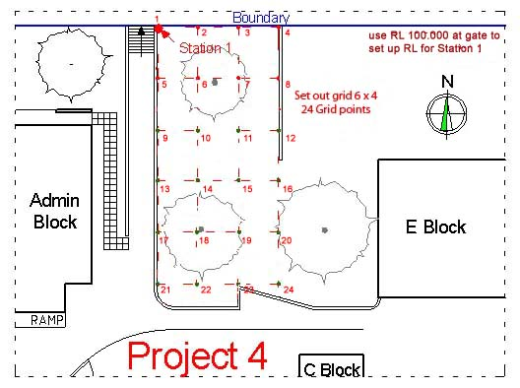
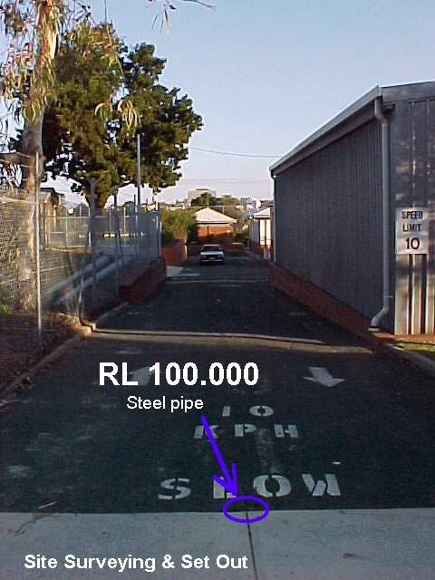
Site datum (Reduced levels)
This is one of four fixed RL’s for the Centre of Construction at the Leederville college.
It’s found on the northeast corner of the college site.
It’s site datum is a temporary benchmark (TBM RL = 100.000 metre).
From this TBM establish the BM (RL) for Station 1. used for this project

